**Hey, I went through your code and I found it was alright. No errors or something of that sort. In case of time limit, I ran your code and found it was running perfectly fine… I am not sure about larger testcases but for sample test cases it was running fine and is expected to run for larger values too.**

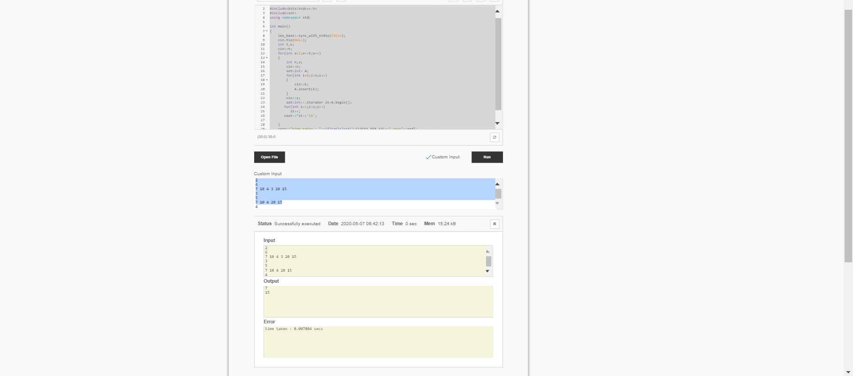

But in case you want more efficient approach, there’s a new library called PBDS. Its just like set with many more added features…. This code using PBDS looks like :

#include <bits/stdc++.h>

#include <ext/pb_ds/assoc_container.hpp>

#include <ext/pb_ds/tree_policy.hpp>

using namespace std;

using namespace __gnu_pbds;

typedef tree<int, null_type, less<int>, rb_tree_tag, tree_order_statistics_node_update> pbds;

int main(){

int test;

cin>>test;

while(test--)

{

pbds A;

int n, num;

cin>>n;

for(int i=0; i<n; i++)

{

cin>>num;

A.insert(num);

}

int k;

cin>>k;

cout << k << "th smallest : " << *A.find_by_order(k-1) << endl;

}

cerr<<"time taken : "<<(float)clock()/CLOCKS_PER_SEC<<" secs"<<endl;

return 0;

}

And it executes in comparatively lesser time :

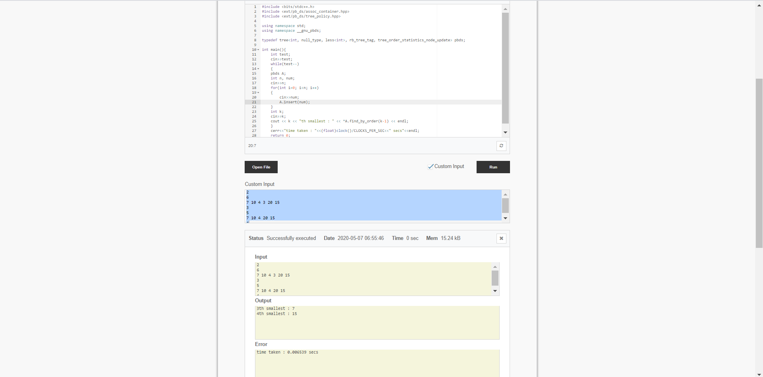

Learn more about it from GeeksforGeeks or Tutorials Point. Its efficient in some cases…